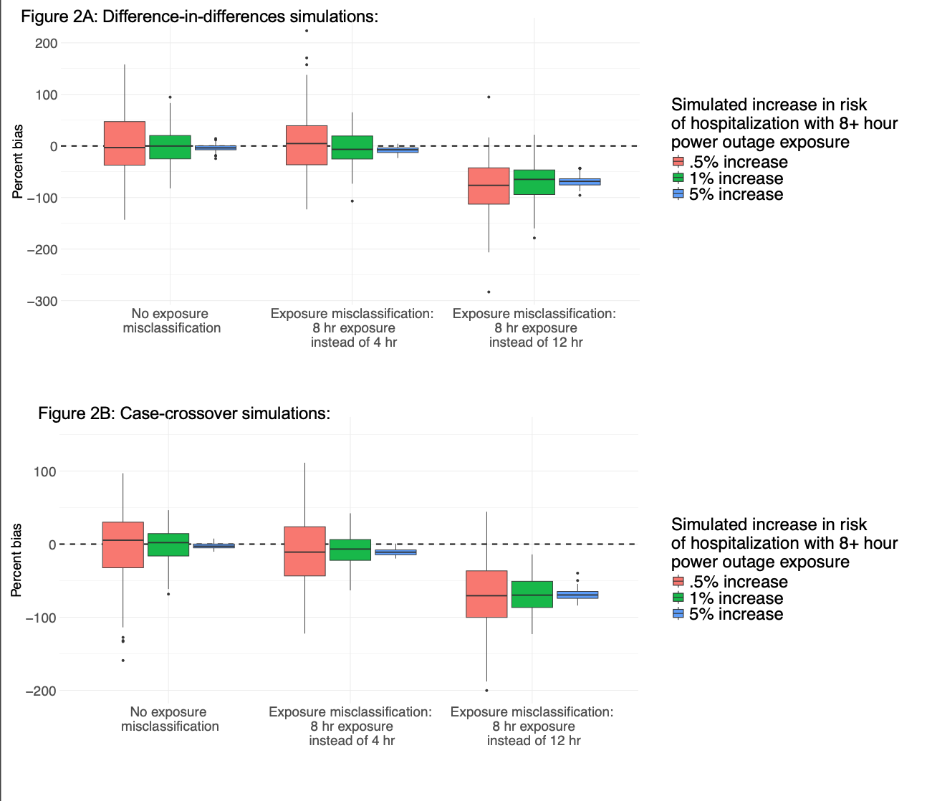**Figure 2**: Results from simulations of the association between power outage exposure and hospitalizations in 100 counties for exposure misclassification scenarios representing wrong assumptions about the health-relevant duration of power outage, for a (A) difference-in-differences design, and (B) case-crossover design. Simulations were repeated 100 times, and boxplots show the distribution of the percent bias of effect estimates in each simulation scenario. There is a dashed line at 0.